DATA ANALYTICS LAB MANUAL

Lab 1 – Environment Setup & Introduction

1. Introduction
In this lab, we set up the required environment for data analytics. We installed necessary tools, created our first notebook, and explored basic concepts of data analysis.

2. Installing Anaconda and Verifying Python
In this step, we installed Anaconda, which provides Python and essential libraries.
Explanation:
Anaconda is a distribution that simplifies package management and environment setup for Python.
We verified Python installation using command prompt.
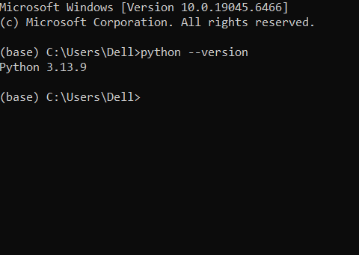
(Showing Anaconda installation or Python version check)

3. Setting Up Jupyter Notebook and Google Colab
In this step, we used Jupyter Notebook and Google Colab for writing and running Python code.
Explanation:
- Jupyter Notebook runs locally on the system
- Google Colab runs online and does not require installation
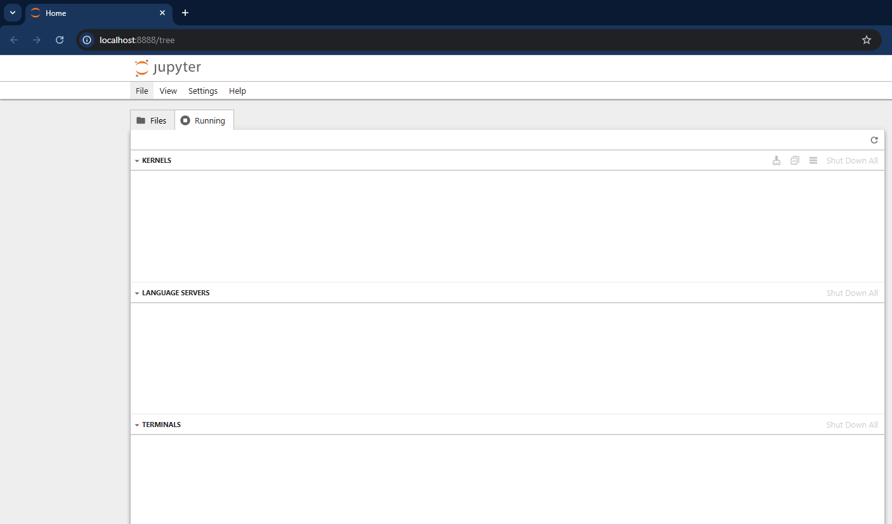
(Showing Jupyter Notebook interface)
📸 Insert Screenshot Here
(Showing Google Colab interface)

4. Installing Essential Libraries
In this step, we installed important Python libraries.
Explanation:
- Pandas → data handling
- NumPy → numerical operations
- Matplotlib → data visualization
- Seaborn → advanced visualization
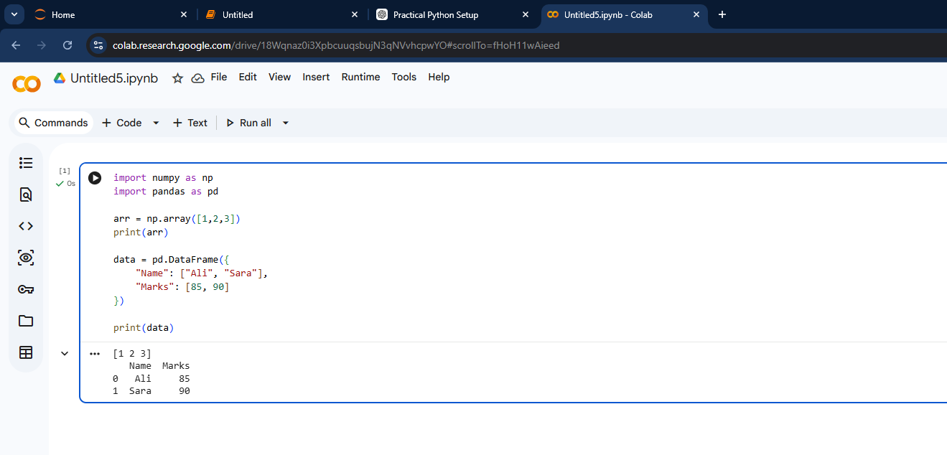
(Showing installation or import of libraries)

5. Creating First Jupyter Notebook
In this step, we created our first notebook.
Explanation:
We wrote simple Python operations such as printing text and basic calculations.
(Showing basic Python code and output)

6. Exploring Data Analytics Use Cases
In this step, we studied how data analytics is used in different industries.
Explanation:
- Healthcare → patient data analysis
- Finance → fraud detection
- E-commerce → recommendation systems
- Education → student performance analysis
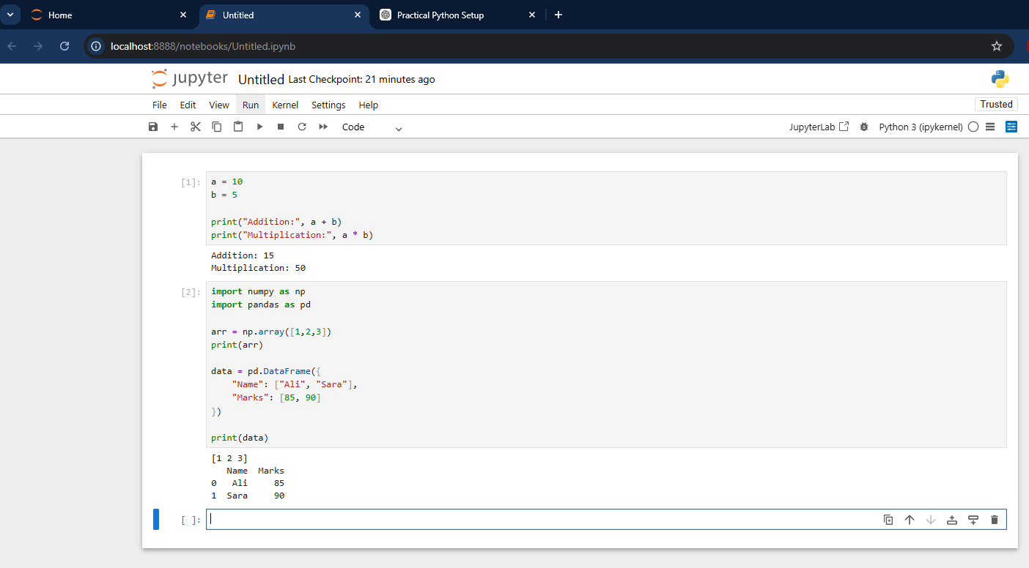
(Optional – notes or examples)

7. Setting Up GitHub and Creating Repository
In this step, we created a GitHub account and our first repository.
Explanation:
GitHub is used to store and manage code online.
We created a repository to upload our lab work.
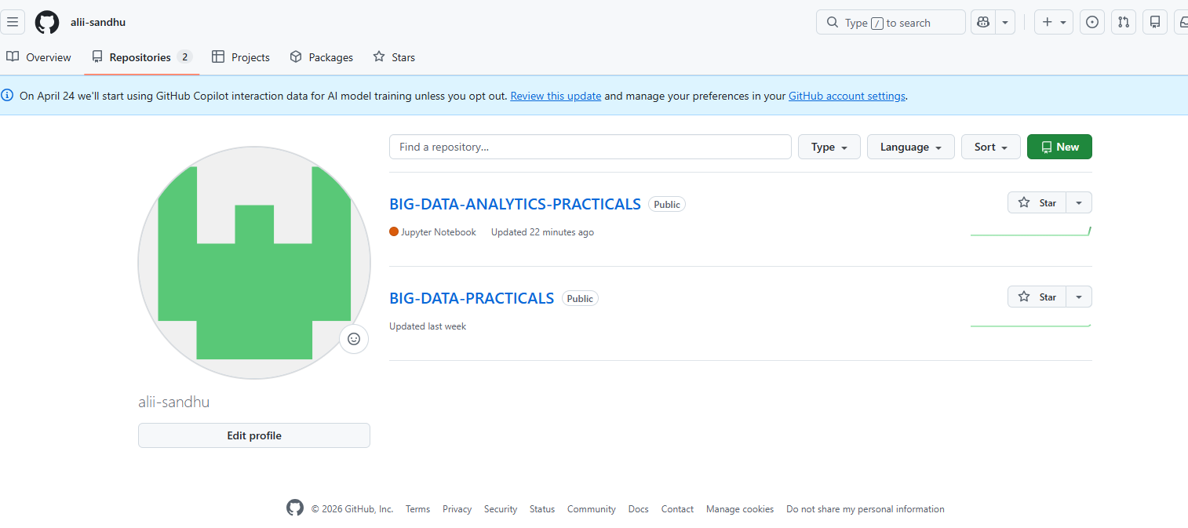
(Showing GitHub repository creation)

8. Deliverable (Screenshots Documentation)
We documented all steps with screenshots including:
- Anaconda installation
- Jupyter Notebook setup
- Google Colab interface
- Library installation
- First notebook
- GitHub repository

9. Conclusion
In this lab, we successfully set up the environment for data analytics. We learned how to install tools, create notebooks, and manage projects using GitHub. This forms the foundation for further data analysis tasks.

10. Output Summary
- Installed Anaconda and verified Python
- Set up Jupyter Notebook and Google Colab
- Installed essential libraries
- Created first Python notebook
- Explored data analytics use cases
- Created GitHub repository

